
CS 120 Web Programming
Assignment 9: Deliverables

Part 1:
- screen shot of your database collection in Atlas (paste below)
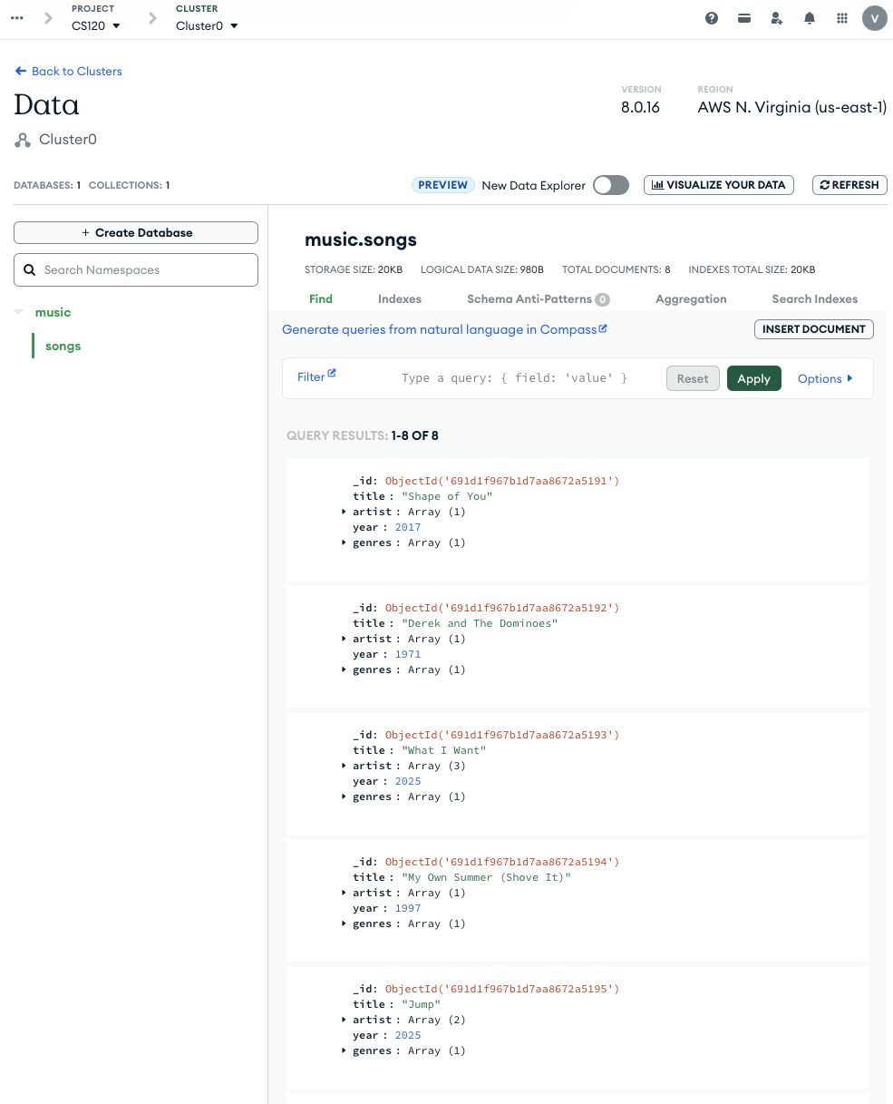
- Query to get all documents from one genre
genre is: Pop
- query is: { "genres": "Pop" }
- screen shot of query running (paste below)
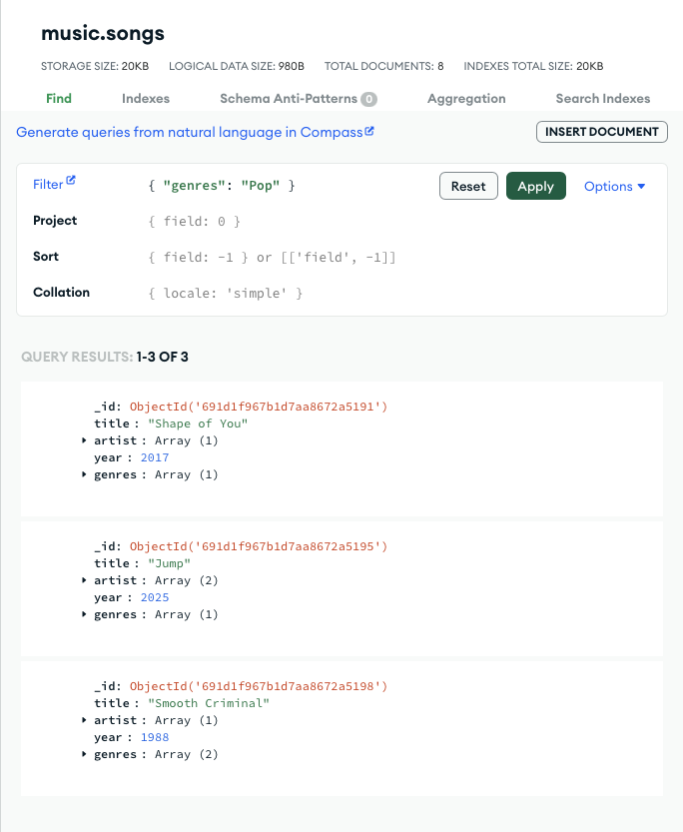
- Part 2: copy/paste the query and results from the console
  - select the database
query: use music
results:
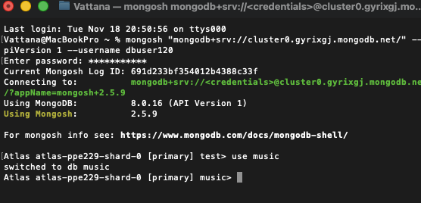
  - show collections in the database
query: show collections
results:
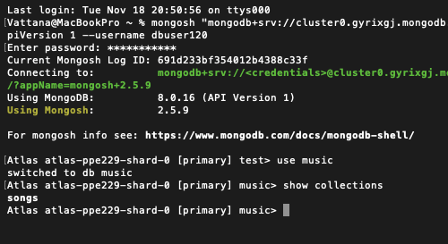
  - show all data for all documents
query: db.songs.find().pretty()
results:
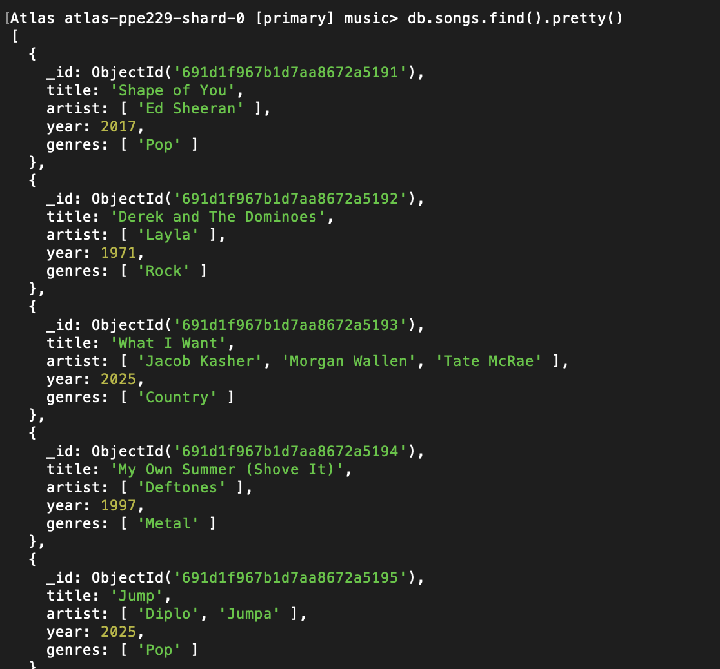
  - show title, artist and genres that correspond to each song
query: db.songs.find({},{title:1, artist:1,genres:1, _id:0})
results:
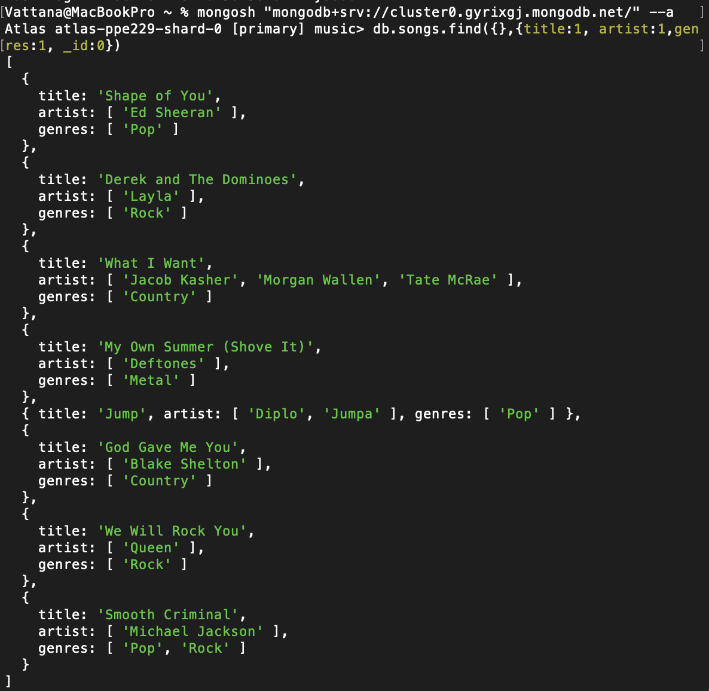
  - show titles for a particular genre
genre: Pop
query: db.songs.find({ genres: "Pop" },{ title: 1, _id: 0 }).pretty()
results:
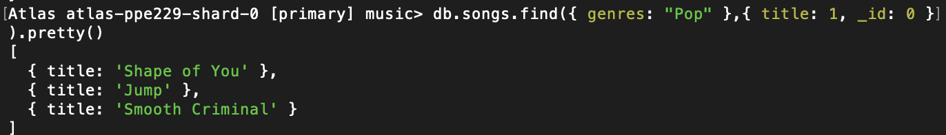
  - show title and artist for songs that belong to 2 genres
genres: Pop, Rock
query: db.songs.find({ genres: { $all: ["Rock", "Pop"] } },{ title: 1, artist: 1, _id: 0 }).pretty()
results:
